Landen Barber
CST472
Deliverable Check #2
At this stage in the project overall I know that I am behind where I need to be. And although I wasn’t able to get as much work done as I hoped since the design review, I was able to spend some time across the three primary aspects that I felt required the most attention: being the firmware testing, PCB development, and the 3D modelling. The time I invested in this was spent learning the basics and getting a better idea of how these all come together and pave the way for future progress.

Testing and Software
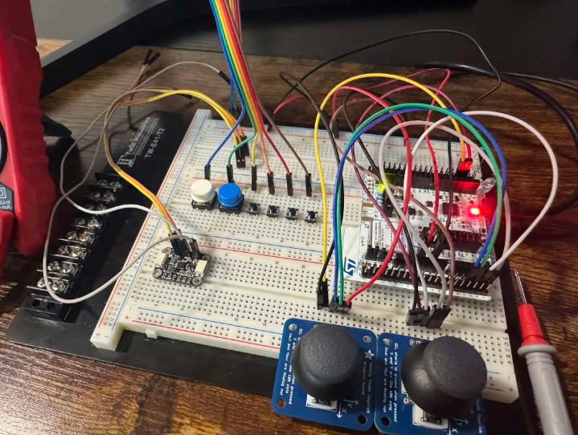
The first and most important aspect that should be done already was finishing testing all the parts together in software. I already knew that each part works individually, via prior testing and multimeter readings, but I still needed to make sure that they could run simultaneously with the current GPIO pin setup. Something small that changed in the software compared to the initial design is now I am using continuous DMA transfers to automatically record the ADCs 12-bit measurements into a register for quick and accurate data reading. Unfortunately, I did get stuck on two issues with the DMA/ADC circular loop involving complete transfer interrupts not being called as they should and finding that making the cycle time longer is crashing the program for a reason I don’t yet understand. These issues are causing the joystick inputs to be read incorrectly if at all and is the reason why this portion is still not completely done. Otherwise, all the components are working with their respective GPIO pin configuration which I plan to reference in the PCB.

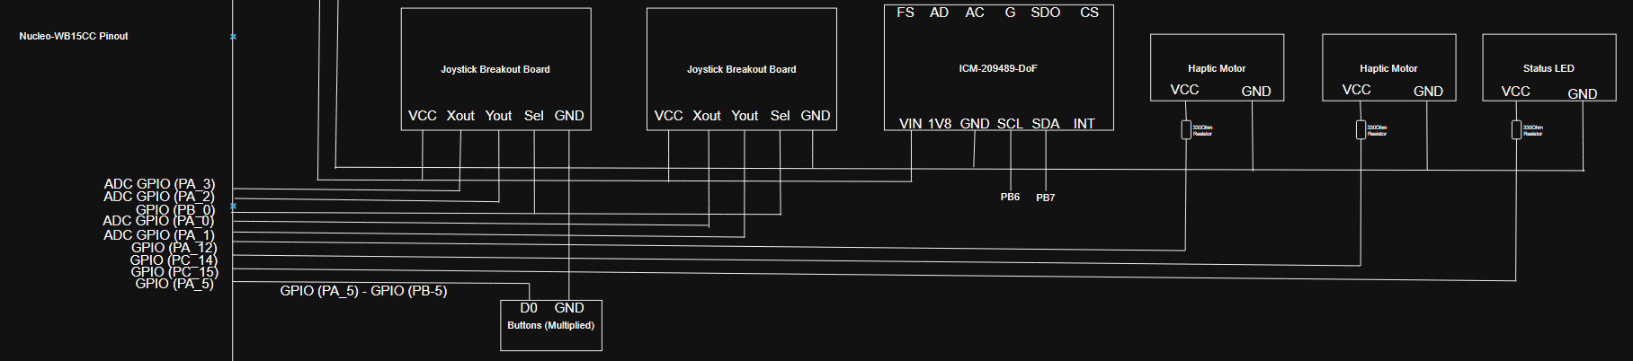
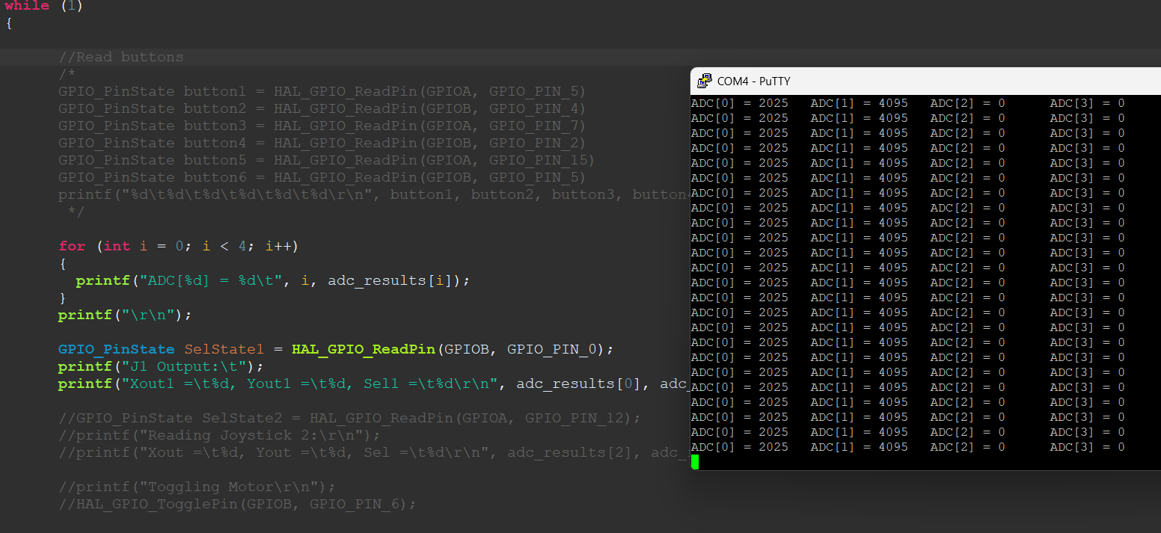

PCB
After spending time trying to resolve those firmware issues and finalizing the GPIO configuration, I moved on to learn more about developing a PCB. While the current design relies on components that came with smaller boards themselves, in hindsight, I realize that ordering these components this way is good for prototyping but makes it a bit more difficult to create the PCB and is not a professional way to go about designing a product. In order to get around this problem and improve the modularity of the prototype board, I ordered new pin sockets for soldering onto PCB when it is made. These will allow me to slot in the component boards alongside a rubber plate to add stability to the prototype boards, also allowing me to remove them at will to place in a future iteration.
Thankfully, all of the parts used in this project provide downloadable schematics that I can easily turn into footprints that can be implemented into PCB design. To reduce the overall horizontal footprint of the device, the internal board will be made a two-level stacked PCB design where the bottom board will hold the heavier components including the microcontroller, charging circuit, and gyroscope module, and the top board will hold the inputs and provide stability.
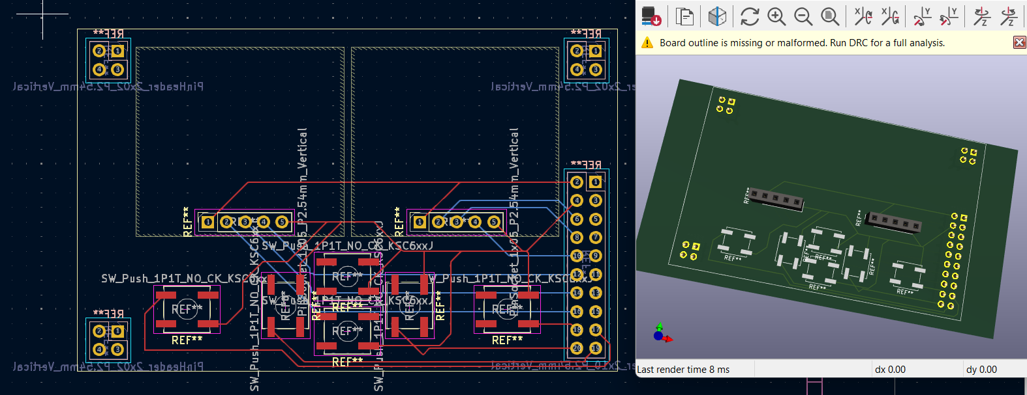
The top board is dedicated primarily to the two joysticks and supporting buttons. Below I have a rudimentary image of the top PCB that holds these parts along with through-hole pin headers in each of the corners which will act both as structural standoffs and electrical connections that can transfer signals between boards without the use of any extra wires or loose cables.

CAD
In parallel with the electrical development portion of this project, I also finally began developing my 3d models using Autodesk Inventor. Below I have simple housing as I start to learn how to properly make 3d models. It may be worth mentioning that this model is still somewhat simple as the foundational structure will rely on the measurements of the PCB to provide a secure base and be durable enough to withstand dropping. As I develop this model further, proper alignment with the I/O will be important to protect the components and future iterations of this model will be focused on adding the handle which will not need to change much depending on the dimensions of the head.
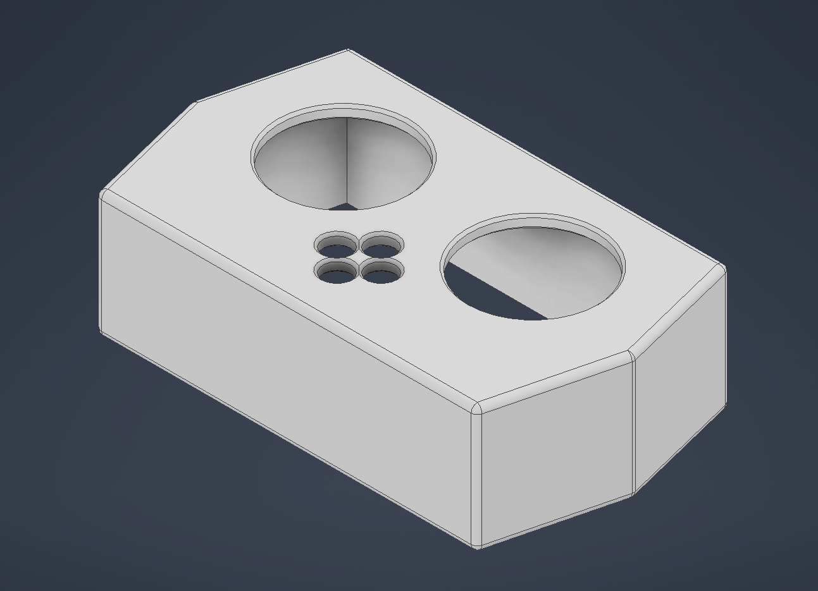

Conclusion and Next Steps
The immediate next step for me will be to fix those firmware issues in order to put my full focus on designing the PCB and potentially being sent to print before the next meeting. I will also continue to update the 3d model to better reflect the dimensions of the PCB and ensure proper alignment of components and mounting. Lastly, I also need to spend some time updating documentation and the schedule to account for recent changes. Having a proper plan should allow me to have a clear idea of what I need to work on and allow me to make some serious progress in the coming weeks.

